HOPE-SIM CLEM software-3D View-V1.0.0

This version of the program has tested on Windows 10 & 11 operating system.

This program is used to perform the fiducial marker-based correlation amount cryo-SIM and cryo-FIB or cryo-EM images, which is used to navigate cryo-FIB milling accurately and cryo-ET data collection.

The program was written by LabVIEW 2019.

1. Data format

Before running this program, the FM images, cryo-FIB images, or cryo-EM images should be formatted as a bmp file.

1.1 For multi-channel FM images (e.g., fiducial beads & virus), the data needs to be saved as image sequence, and named as “beads-01.bmp” of “virus-01.bmp”, and placed in two different folders and named as “c1” and “c3”;

1.2 Z projection image of fiducial markers’ fluorescence image stack is need, and the file should be named as “bf-beads.bmp”;

1.3 FIB or EM image should be named as “fib.bmp”.

The following is the interface of the program.

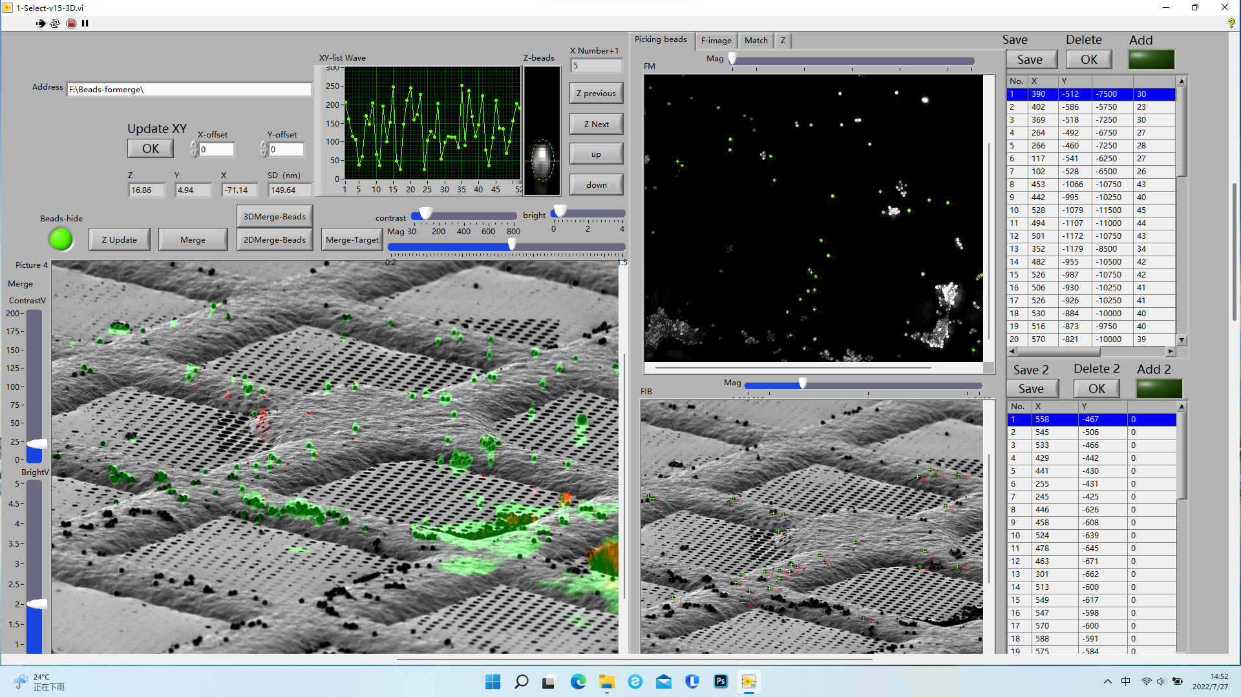

2. Correlation

2.1 Load CLEM data folder address to file address loader as : “C:\Users\Desktop\CLEMtestdata\”;

2.2 Running the 3D View program;

2.3 Pick the corresponding fiducial markers on FM and FIB (or EM) pictures in turn as many as possible;

2.4 Click “Z Updata” and “merge” button, and then “XY-list Wave” will show the deviation of each marker. To further optimize the correlation between two correlative images, the Z height of fluorescent microspheres could be manually adjusted according to the shapes of the fluorescence microspheres by click “up” or “down” button of “Z-beads”. And the square deviation is shown in “SD(nm)”

2.5 Click “3D Merge-Beads” or “2D Merge-Beads” to check the correlation efficacy;

2.6 Contrast and bright value is adjustable individually;

2.7 Click “Merge-Target” to show the correlation results；

2.8 Save the results.

3 Test data

A set of formatted test data named as “CLEMtestdata” is given in attachment.